**Steps and Commands used to run the website through command prompt:**

1.Move to folder conataining main.py script.

2. Run set FLASK_APP=main

3.Run set FLASK_ENV=development

4.flask run

5. Run SQLite editor and add related database file given in thse same folder mentioned above.

5.Copy & paste the URL in browser window.

6.Webpage will be loaded and you can perform operations on your own from

Frontend as well as from backend.

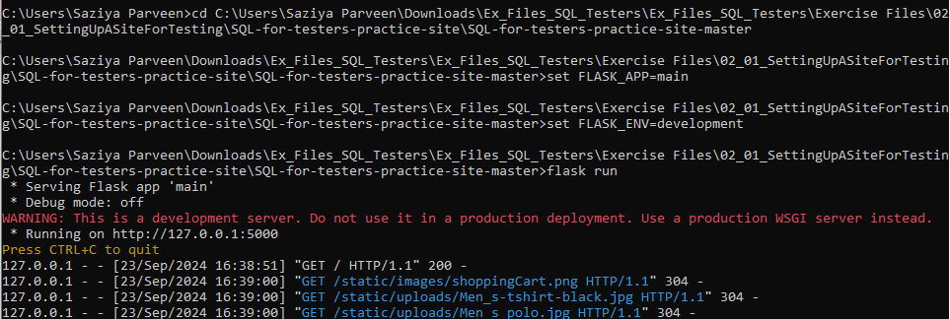

**select * from products inner join cart**

**on cart.productid=products.productid;**

127.0.0.1 - - [23/Sep/2024 17:54:22] "GET /cart HTTP/1.1" 200 -

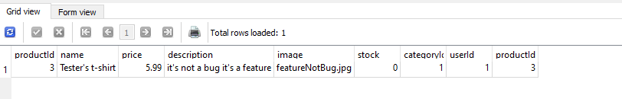

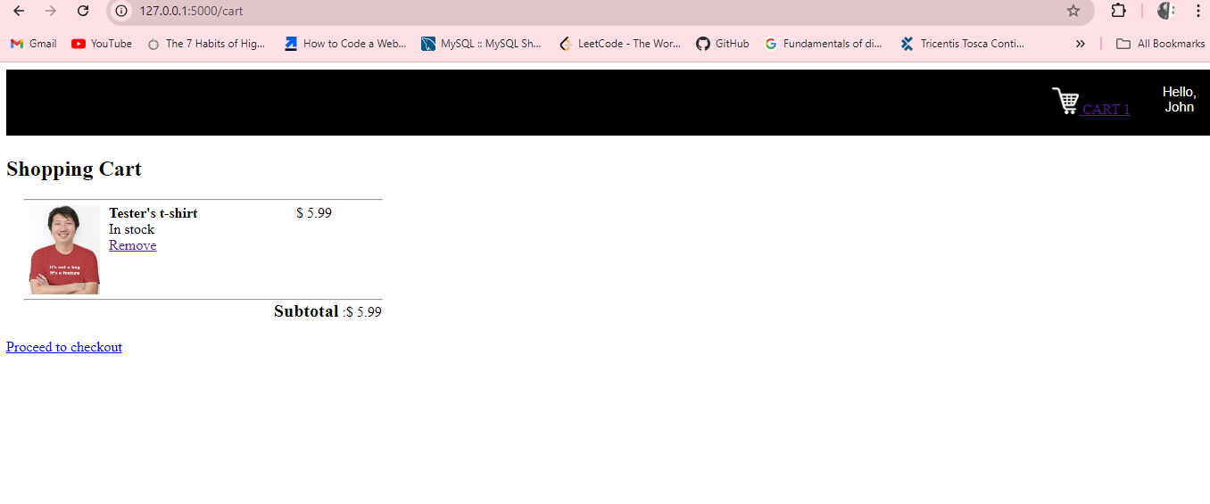

**select * from users;**

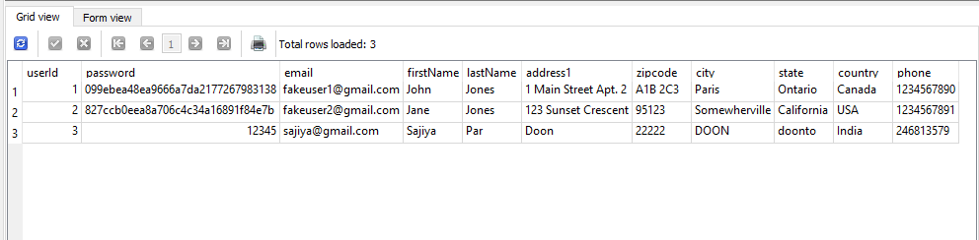

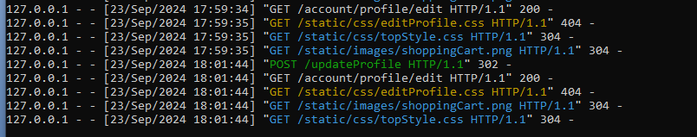

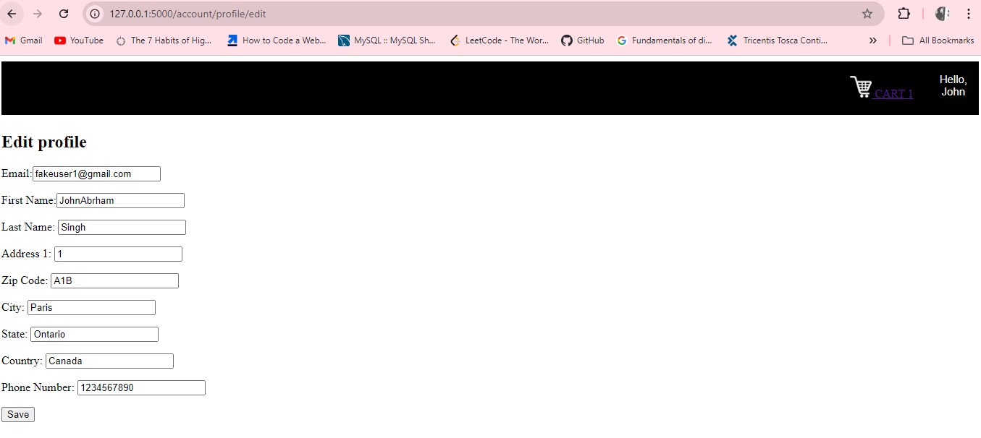

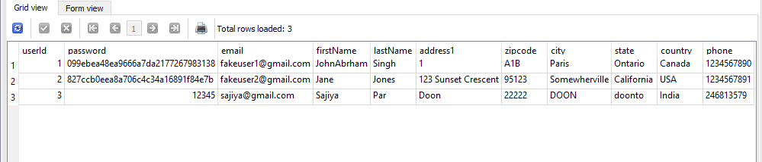

**Update:**

**update products set name="very long" where productid=5;**

**127.0.0.1 - - [23/Sep/2024 17:05:14] "GET /productDescription?productId=5 HTTP/1.1" 200 -**

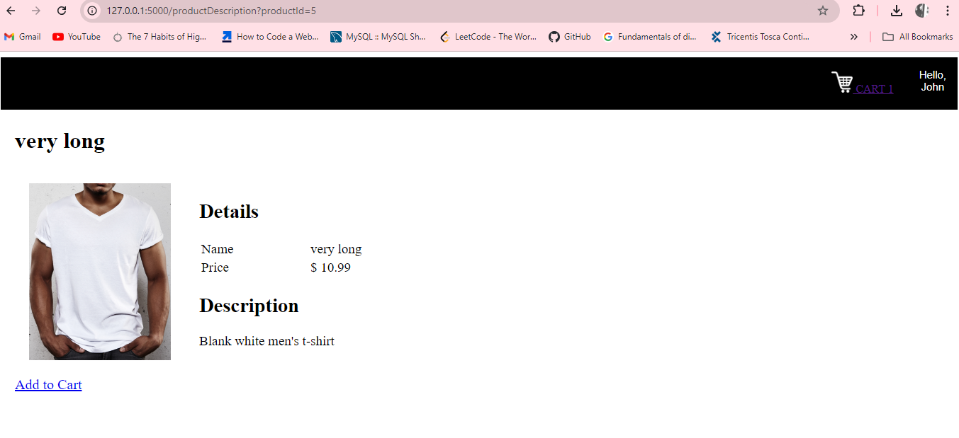



**Update products set price=100 where name ="Men's Polo";**

127.0.0.1 - - [23/Sep/2024 17:44:58] "GET / HTTP/1.1" 200 -



**delete from cart; > > “Empty cart”**

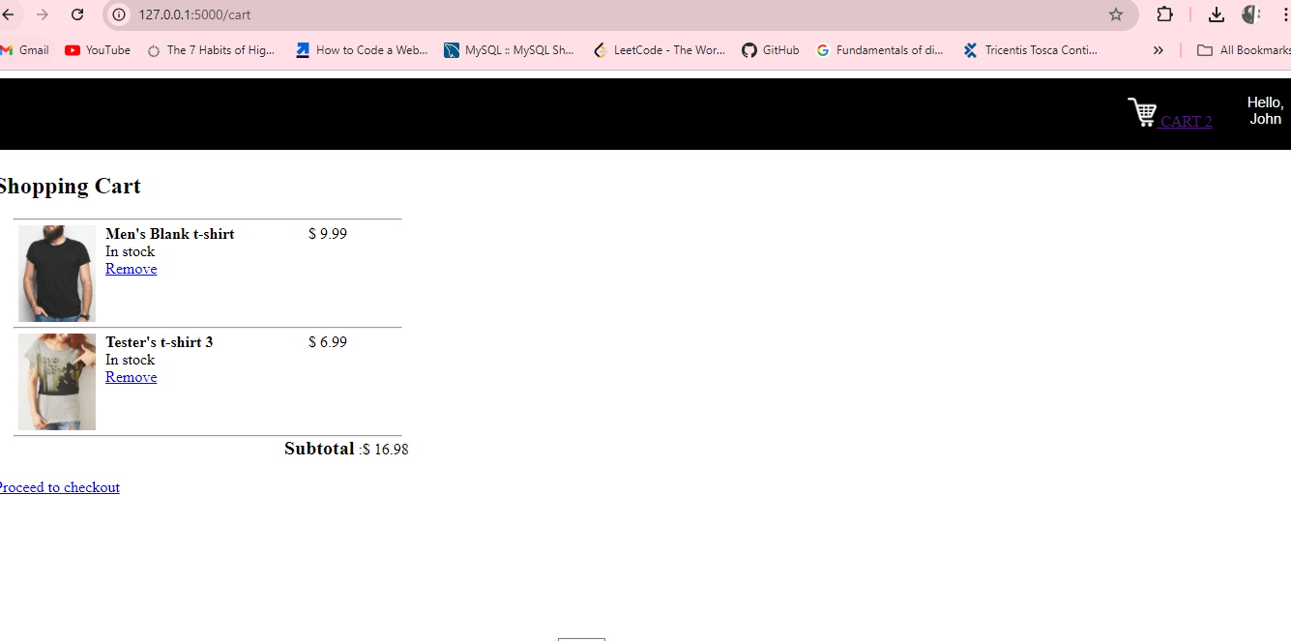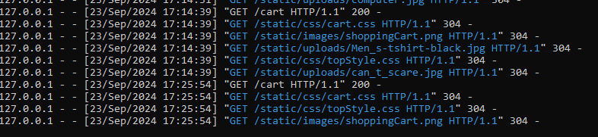

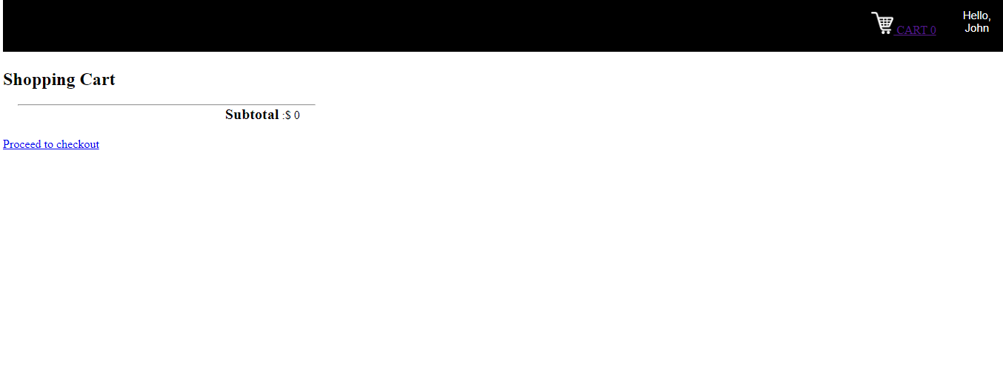

delete from products where productid=8 and categoryId=2;

select count(*) from products;

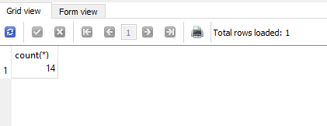



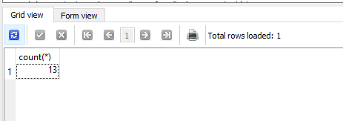

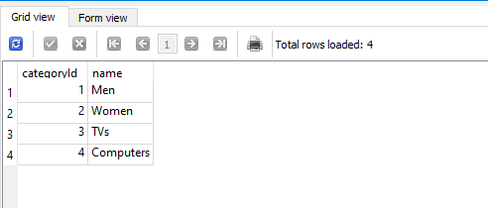

select * from products inner join cart

on cart.productid=products.productid;

select * from categories;

select * from cart;

select * from users;

select users from database;

insert into users values(3,12345,'sajiya@gmail.com','Sajiya','Par','Doon','22222','DOON','doonto','India','246813579');

select p.price,p.description,c.name from products p join categories c

on c.categoryId=p.categoryId

where p.price>20 order by price;

select * from products p join cart c on p.productid=c.productid;

select * from products;

delete from categories where categoryId=2;

delete from products where productid=8 and categoryId=2;

delete from cart;

update products set name="very long" where productid=5;

Update products set price=100 where name ="Men's Polo";

select * from products;

select count(*) from products;

Insert into products (productid) select productid+1 from products;

select * from classes;

select * from enrollments;

select * from roles;

select * from users;

select u.firstName from users u join enrollments e on u.userid=e.userid join

classes c on c.classCode=e.classcode join

roles r on r.roleId=e.roleid

where c.classname="Math" and r.roleType="Teacher";